
Courier Management System (CMS)

Project Documentation

TEAM MEMBERS:

AKASHKUMAR C

ALAMEEN M

ANBARASU M

ANANDHU A

NAN MUDHALVAN DEPARTMENT- STAFF

V SAKTHIVEL - HOD

A SIVASAGARI - TUTIOR

- INTRODUCTION
  - Project Overview :
Courier and logistics companies face challenges in efficiently managing shipments and deliveries due to manual operations and disconnected systems. These issues lead to delayed updates, poor customer visibility, and operational inefficiencies.
The Courier Management System (CMS) is a Salesforce-based cloud solution that centralizes shipment booking, tracking, delivery agent assignment, automated status updates, billing, and analytics. The system improves operational efficiency, enhances customer satisfaction, and provides real-time business insights.

Purpose :

The purpose of the Courier Management System (CMS) is to automate and centralize courier and logistics operations using the Salesforce platform. The system aims to replace manual and fragmented processes with an integrated digital solution that enables efficient shipment booking, real-time tracking, delivery agent assignment, automated notifications, billing, and performance reporting. By providing a single, unified platform for managing shipments across multiple branches, CMS improves operational visibility, enhances customer communication, reduces delays and errors, and supports faster decision-making through analytics. Ultimately, the system is designed to increase service efficiency, customer satisfaction, and overall business profitability.

IDEATION PHASE

Problem Statement (Customer Problem Statement Template)

PS | I am (Customer) | I’m trying to | But | Because | Which makes me feel
PS-1 | Branch Manager | manage shipments efficiently | tracking is manual | systems are disconnecte d | stressed
PS-2 | Customer | track parcels | updates are delayed | no centralized system | uncertain

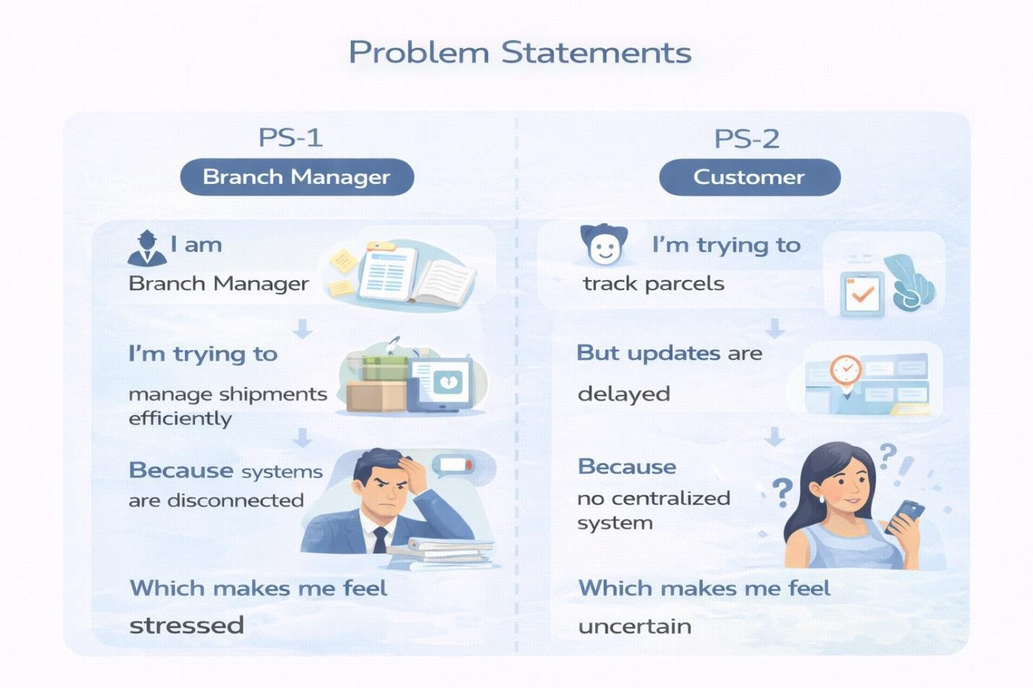

  - Empathy Map Canvas
User Persona: Branch Manager
    - Think & Feel: Concerned about delays & errors
    - Hear: Customer complaints
    - See: Registers & spreadsheets
    - Say & Do: Manual follow-ups
    - Pain: Delivery conflicts & missed updates
    - Gain: Automated tracking & dashboards

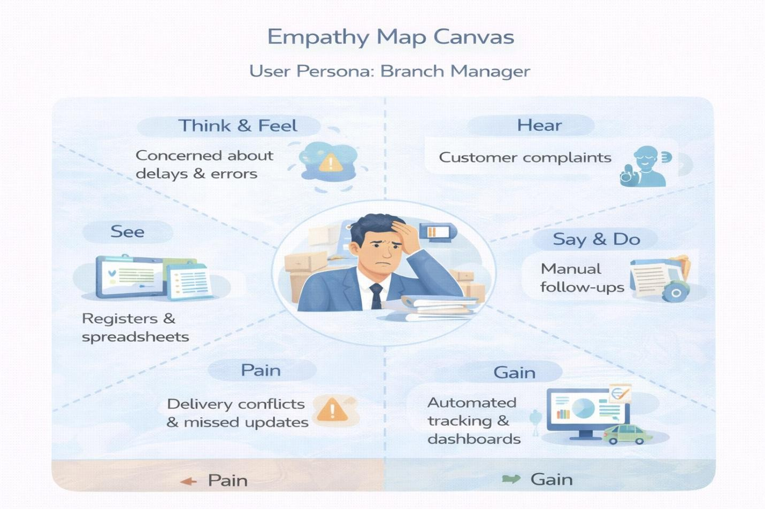

Brainstorming & Idea Prioritization
Ideas Considered
    - Manual registers
    - Spreadsheet tracking
    - Standalone portal
    - Salesforce CRM
Final Selection
Salesforce CRM selected due to:
    - Automation

    - Scalability
    - Real-time visibility

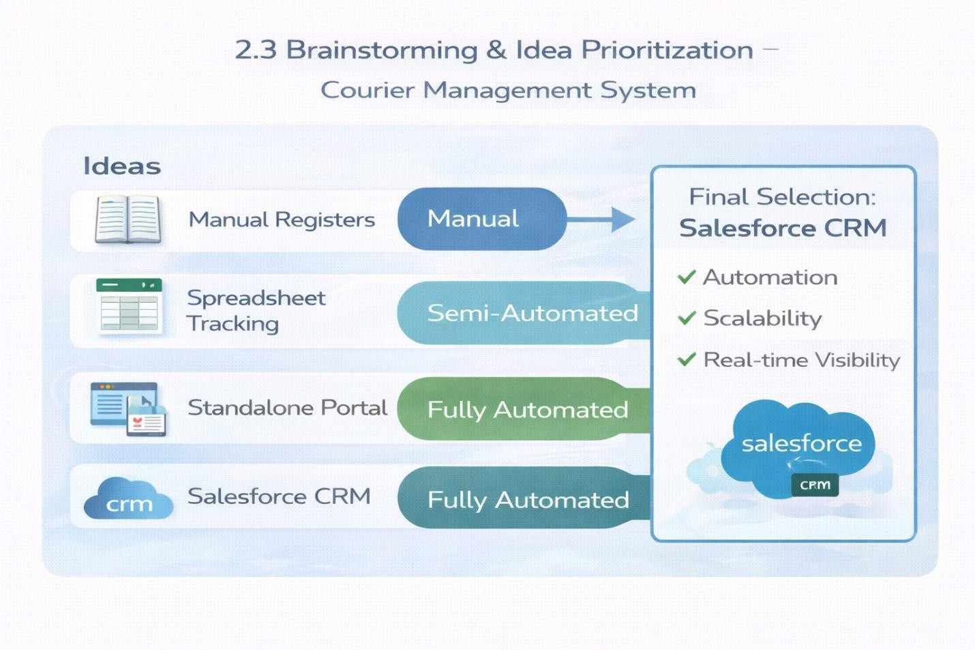

REQUIREMENT ANALYSIS PHASE

Customer Journey Map
Stages:
    - Booking → Shipment Creation → Agent Assignment → Transit → Delivery Update → Invoice → Reporting

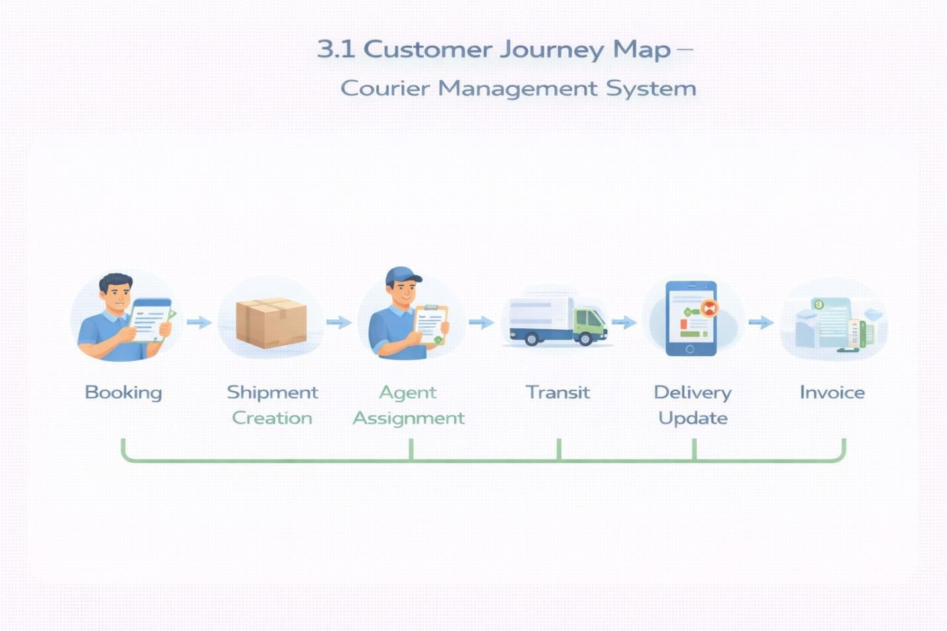

Solution Requirements
Functional Requirements

FR No | Requirement
FR-1 | Customer management
FR-2 | Shipment booking
FR-3 | Delivery agent assignment
FR-4 | Real-time status updates

FR-5 | Invoice generation
FR-6 | Reports & dashboards

Non-Functional Requirements

NFR | Description
Usability | Easy Lightning interface
Security | Role-based access control
Reliability | Error-free automation
Performance | Fast tracking updates
Availability | 24/7 cloud access
Scalability | Supports growing branches

Data Flow Diagram
Flow:
Customer Input → Shipment Creation → Validation → Agent Assignment → Delivery Update → Invoice → Reports

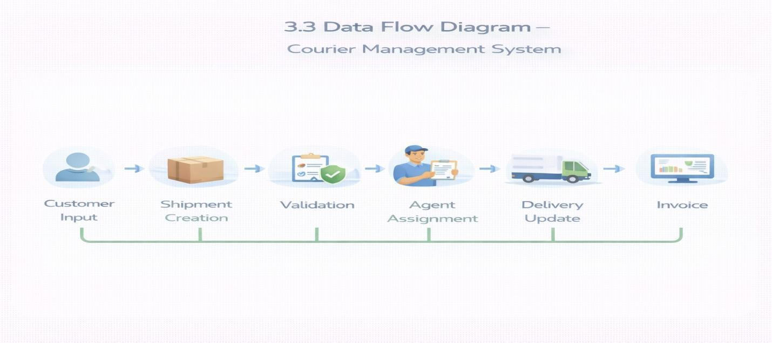
  - Technology Stack
Layer | Technology
UI | Salesforce Lightning
Logic | Salesforce Flows
Database | Salesforce Objects
Automation | Validation Rules, Flows
Security | Profiles, Roles
Reporting | Reports & Dashboards

PROJECT DESIGN PHASE

Problem–Solution Fit
CMS eliminates fragmented courier operations by automating shipment tracking, delivery assignment, billing, and reporting within a centralized Salesforce platform.

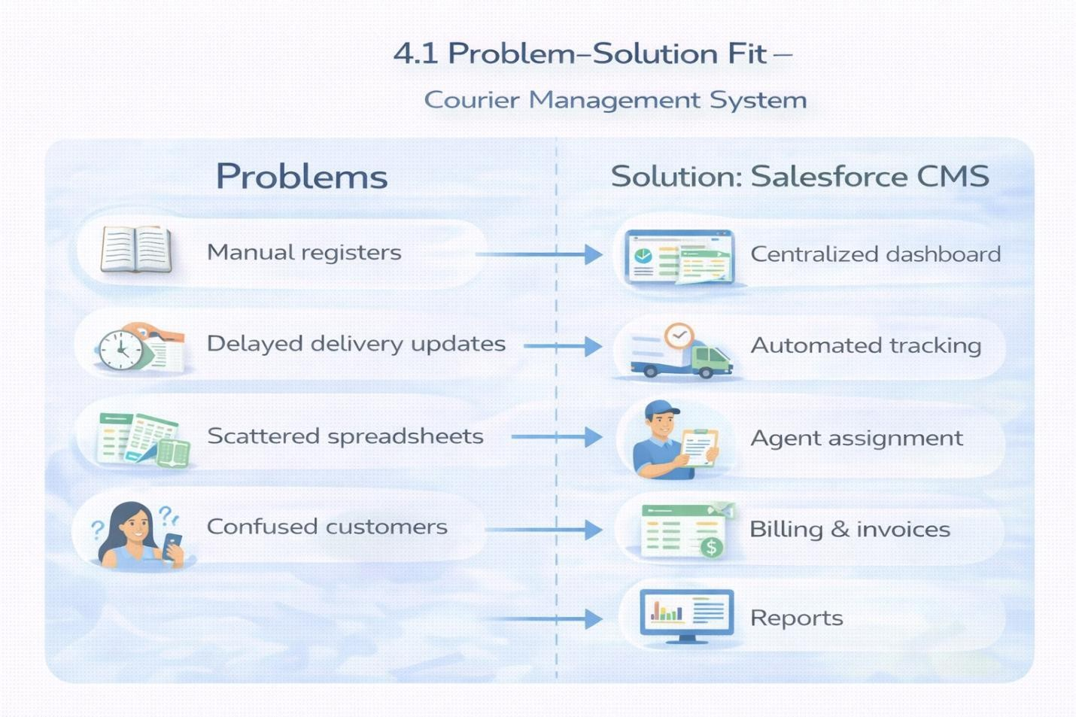

Proposed Solution
Functional Requirements

Parameter | Description
Problem | Manual shipment management
Solution | Salesforce CMS

Innovation | Automated tracking & billing
Impact | Faster deliveries
Business Model | Courier services
Scalability | Multi-branch ready

Solution Architecture
Components:
    - Customer Object ● Shipment Object
    - Delivery Agent Object
    - Branch Object
    - Delivery Update Object
    - Invoice Object
    - Flows
    - Reports
    - Dashboards

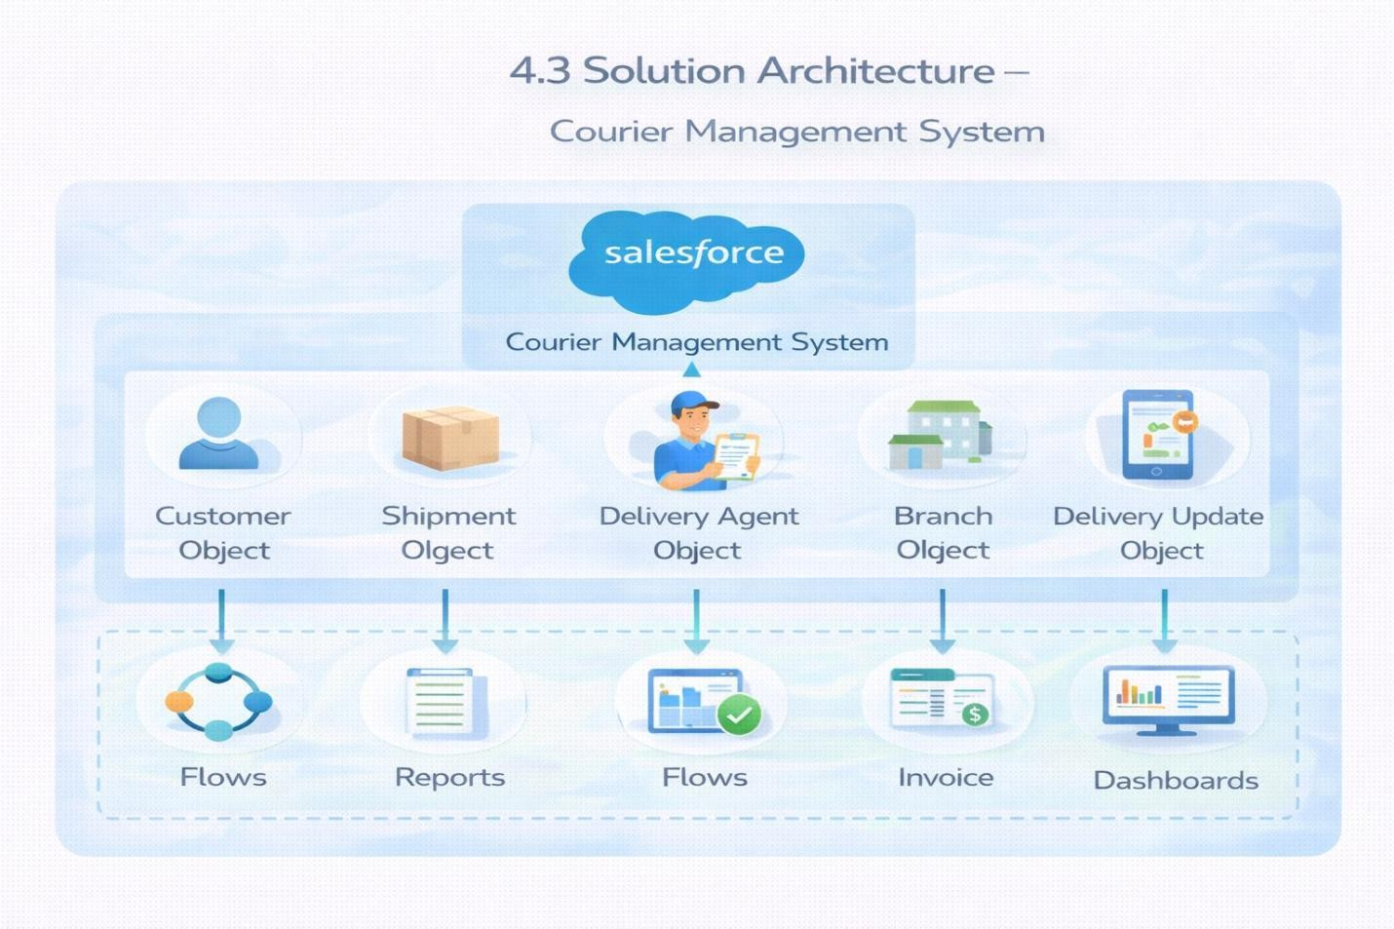

PROJECT PLANNING & SCHEDULING

Project Planning
    - Agile methodology
    - Epics → Stories → Story Points
    - Sprint-based execution
    - Velocity calculation used for estimation

Salesforce Account

Introduction:

New to Salesforce and unsure where to start? Curious how real business applications—like loan processing and payment tracking—can be built on the platform? You’re in the right place.
Welcome to the Loan Management System project!

Salesforce offers powerful tools that help automate processes, improve accuracy, and manage customer operations with ease. In this project, you’ll learn how Salesforce can streamline lending workflows—from borrower onboarding to loan approval, EMI tracking, and document verification.

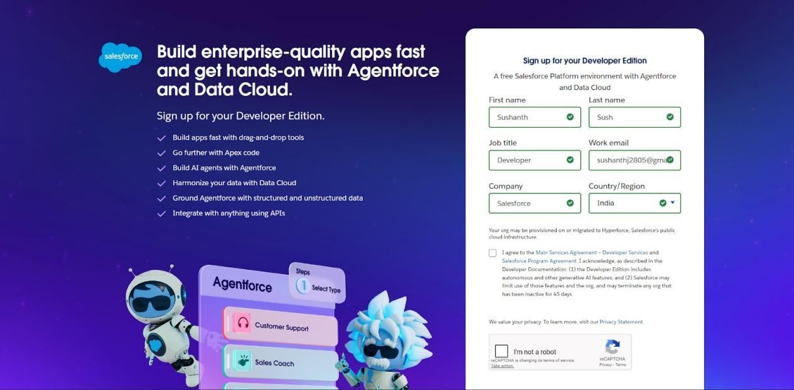
- First name & Last name
- Email
- Job Title: Developer
- Company: College Name
- Country: India
Click on sign me up after filling these.

Account Activation
- Go to the inbox of the email that you used while signing up. Click on the verify account to activate your account. The email may take 10-30 mins and sometimes 2 hours.
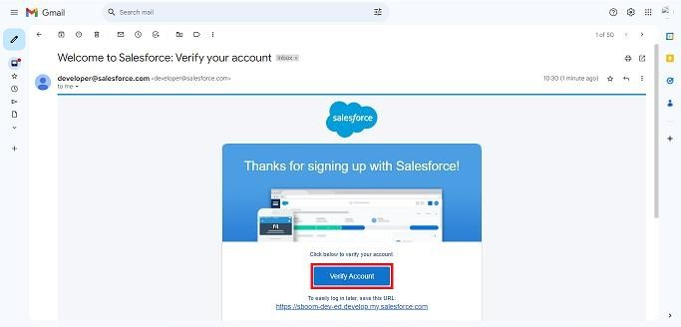

- Click on Verify Account
- Give a password and answer a security question and click on change password.
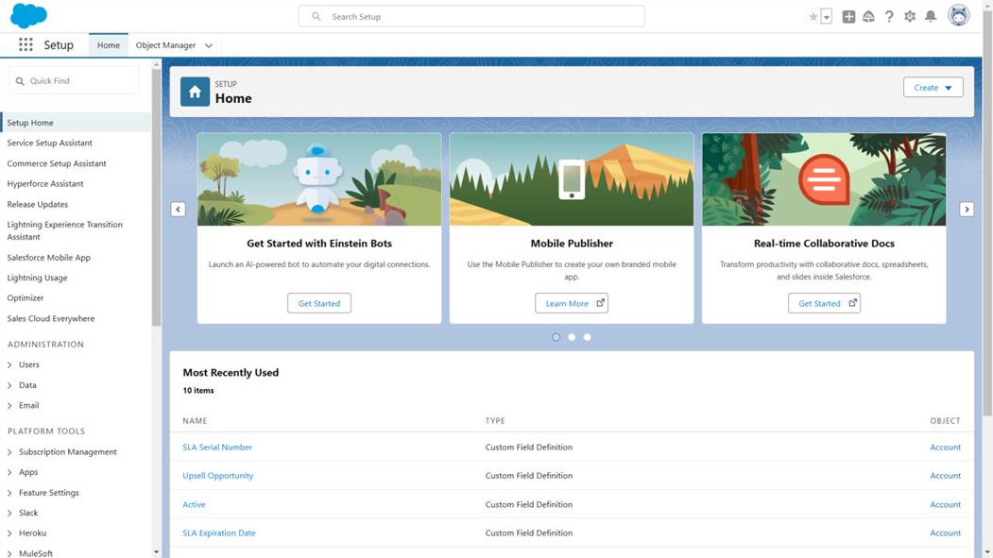
- Then you will redirect to your salesforce setup page.

Object:

Custom Objects Created:
- Customer c – stores customer personal and contact information

- Shipment c – manages parcel details, source, destination, and tracking information

- Delivery_Agent c – maintains delivery agent profiles and branch details

- Branch c – represents courier branch offices
- Delivery_Update c – stores status updates for each shipment

- Invoice c – manages billing details for delivered shipments

Relationships:

Customer → Shipment (Lookup) Shipment → Delivery_Agent (Lookup) Delivery_Agent → Branch (Lookup)
Delivery_Update → Shipment (Master-Detail) Invoice → Shipment (Lookup)

Steps to Implement :

Create Customer Object

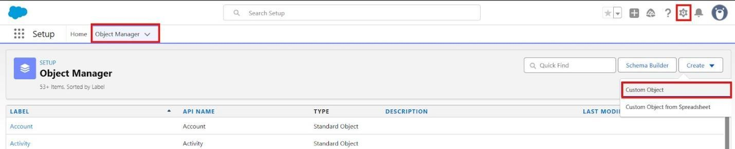

  - Enter the following details:

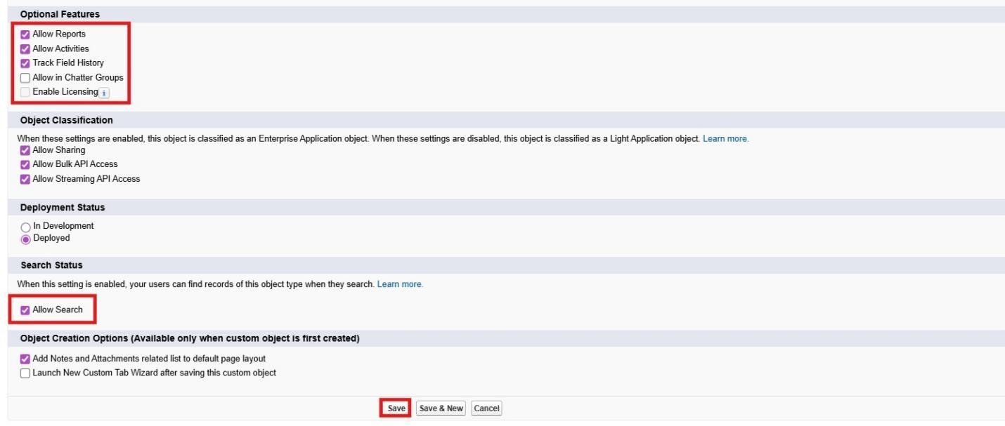

Create Shipment Object

    - Go to Setup → Object Manager → Create → Custom Object

    - Enter:
      - Label: Shipment

      - Plural Label: Shipments

      - Record Name: Tracking Number (Auto Number)

    - Example Format: SHP-{00000} Starting Number: 0
    - Enable:
Allow Reports

      - Track Field History

    - Click Save

      - ​

Create Delivery_Agent Object

- Setup → Object Manager → Create → Custom Object

- Enter:
  - Label: Delivery Agent

  - Plural Label: Delivery Agents

  - Record Name: Agent Name (Text)

- Enable:
  - Allow Reports

  - Track Field History

- Click Save

Create Branch Object

- Setup → Object Manager → Create → Custom Object

- Enter:
  - Label: Branch

Plural Label: Branches
  - Record Name: Branch Name (Text)

- Enable:
  - Allow Reports

- Click Save.

Create Delivery_Update Object

- Setup → Object Manager → Create → Custom Object

- Enter:
  - Label: Delivery Update

  - Plural Label: Delivery Updates

  - Record Name: Update Number (Auto Number)

- Example Format: UPD-{0000} Enter Starting number : 0
- Enable:
  - Allow Reports

  - Track Field History

- Click Save.

Create Invoice Object

- Setup → Object Manager → Create → Custom Object

- Enter:
  - Label: Invoice
  - Plural Label: Invoices
  - Record Name: Invoice Number (Auto Number)
- Example Format: INV-{0000} Enter Starting number: 0
- Enable:
  - Allow Reports

Create Invoice Object

- Setup → Object Manager → Create → Custom Object

- Enter:
  - Label: Invoice

  - Plural Label: Invoices

  - Record Name: Invoice Number (Auto Number)

- Example Format: INV-{0000} Enter Starting number: 0
- Enable:
  - Allow Reports

  - Track Field History

- Click Save

Tabs

Activity 1: Creating a Tab for Customer Object

- Click Home, type Tabs in Quick Find, and select Tabs.

- Under Custom Object Tabs, click New.

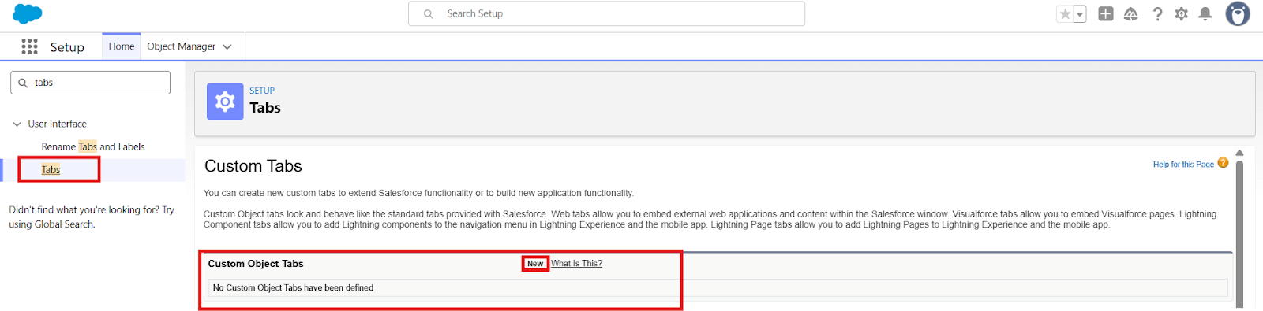

- For Object, select Customer.

- For Tab Style, choose any icon.

- Leave all default settings as they are.

- Click Next, Next, and Save.

Creating a Tab for Shipment Object
- Click Home, type Tabs in Quick Find, and select Tabs.

- Under Custom Object Tabs, click New.

- For Object, select Shipment.

- Choose any Tab Style.

- Keep defaults unchanged.

- Click Next, Next, and Save.

Creating a Tab for Delivery Agent Object
- Click Home, type Tabs in Quick Find, and select Tabs.

- Under Custom Object Tabs, click New.

- For Object, select Delivery Agent.

- Pick any Tab Style.

- Leave default settings.

- Click Next, Next, and Save.

Creating a Tab for Branch Object
- Click Home, type Tabs in Quick Find, and select Tabs.

- Under Custom Object Tabs, click New.

- For Object, select Branch.

- Choose any Tab Style.

- Keep all defaults.

- Click Next, Next, and Save.

Creating a Tab for Delivery Update Object

- Click Home, type Tabs in Quick Find, and select Tabs.

- Under Custom Object Tabs, click New.

- For Object, select Delivery Update.

- Select any Tab Style.

- Keep default configurations.

- Click Next, Next, and Save.

Creating a Tab for Invoice Object
- Click Home, type Tabs in Quick Find, and select Tabs.

- Under Custom Object Tabs, click New.

- For Object, select Invoice.

- Select any Tab Style.

- Leave defaults unchanged.

- Click Next, Next, and Save.

Fields & Relationships
Creation of fields for the Customer Object

Field Name | API Name | Data Type | Required | Description
Customer Name | Name | Text | Yes | Full name of customer
Email | Email c | Email | Yes | Customer email
Phone | Phone c | Phone | Yes | Customer contact number
Address | Address c | Text Area | Yes | Customer address
Customer Type | Customer_Type c | Picklist | Yes | Regular / Business
City | City c | Text | No | Customer city
State | State c | Text | No | Customer state
Pincode | Pincode c | Text | No | Postal code
Is Active | Is_Active c | Checkbox | No | Active status

Creation of fields for the Shipment Object
Field Name | API Name | Data Type | Required | Description
Tracking Number | Name | Auto Number | Yes | Unique ID
Customer | Customer c | Lookup(Customer) | Yes | Related customer
Source Address | Source_Address c | Text Area | Yes | Pickup location
Destination Address | Destination_Address_  _c | Text Area | Yes | Delivery location
Weight | Weight c | Number | Yes | Parcel weight
Price | Price c | Currency | Yes | Shipping charge
Status | Status c | Picklist | Yes | Shipment status
Expected Date | Expected_Date c | Date | Yes | Delivery estimate
Assigned Agent | Assigned_Agent c | Lookup(Delivery_Age nt) | No | Delivery agent
Shipment Type | Shipment_Type c | Picklist | Yes | Domestic/International

Creation of fields for Delivery_Agent Object

Field Name | API Name | Data Type | Required
Agent Name | Name | Text | Yes
Email | Email c | Email | Yes
Phone | Phone c | Phone | Yes
Branch | Branch c | Lookup | Yes
Status | Status c | Picklist | Yes
Joining Date | Joining_Date c | Date | No

Creation of fields for Branch Object

Field Name | API Name | Data Type | Required
Branch Name | Name | Text | Yes
Branch Code | Branch_Code c | Text | Yes
City | City c | Text | Yes
State | State c | Text | Yes
Manager Name | Manager_Name c | Text | No

Creation of fields for Delivery_Update Object

Field Name | API Name | Data Type | Required
Update Number | Name | Auto Number | Yes
Shipment | Shipment c | Master-Detail | Yes
Status | Status c | Picklist | Yes
Update Date | Update_Date c | DateTime | Yes
Remarks | Remarks c | Text | No

Creation of fields for Invoice Object

Field Name | API Name | Data Type | Required
Invoice Number | Name | Auto Number | Yes
Shipment | Shipment c | Lookup | Yes
Amount | Amount c | Currency | Yes
Invoice Date | Invoice_Date c | Date | Yes
Payment Status | Payment_Status c | Picklist | Yes
Relationships :

Child Object | Field | Parent Object | Type
Shipment | Customer c | Customer | Lookup
Shipment | Assigned_Agent c | Delivery_Agent | Lookup
Delivery_Agent | Branch c | Branch | Lookup
Delivery_Update | Shipment c | Shipment | Master- Detail
Invoice | Shipment c | Shipment | Lookup

Validation Rules :

Validation rules are applied when a user tries to save a record and are used to check if the data meets specified criteria. If the criteria are not met, the validation rule triggers an error message and prevents the user from saving the record until the issues are resolved.

Create Validation Rules on Customer c

Validation Rule: Email Must Not Be Blank

Steps:
  - Click the Gear icon → Setup

  - Go to Object Manager

  - Search and select Customer c

  - From the left menu, click Validation Rules

  - Click New

  - Rule Name: Email_Required

  - Check Active

In Error Condition Formula, paste: ISBLANK(Email c)
  - Click Check Syntax

  - Error Message: Email is required.

  - Error Location: Field → Email

  - Click Save.

Validation Rule: Phone Must Be 10 Digits

Steps:
  - Setup → Object Manager → Customer c

  - Validation Rules → New

  - Rule Name: Validate_Phone_Number

  - Check Active

Formula:

LEN(Phone c) <> 10
  - Check Syntax

  - Error Message: Phone number must be 10 digits.

  - Error Location: Field → Phone

  - Save

Validation Rule: Pincode Must Be 6 Digits

Steps:
  - Setup → Object Manager → Customer c

  - Validation Rules → New

  - Rule Name: Validate_Pincode

  - Active → Yes
  - ​

Formula:

LEN(Pincode c) <> 6
  - Error Message: Pincode must be 6 digits.

  - Location: Field → Pincode

  - Save

Create Validation Rules on Shipment c

Validation Rule: Weight Must Be Greater Than Zero

Steps:
  - Setup → Object Manager → Shipment c

  - Click Validation Rules → New

  - Rule Name: Validate_Weight

  - Active → Checked

Formula:

Weight c <= 0

  - Check Syntax

Error Message: Weight must be greater than zero.

  - Location: Field → Weight
  - Save

Validation Rule: Price Must Be Greater Than Zero

Steps:
  - Setup → Object Manager → Shipment c

  - Validation Rules → New

  - Rule Name: Validate_Price

  - Active → Yes

Formula:
Price c <= 0

  - Error Message: Price must be greater than zero.

  - Location: Field → Price

  - Save

Validation Rule: Expected Date Cannot Be in the Past

Steps:
  - Setup → Object Manager → Shipment c

  - Validation Rules → New

  - Rule Name: Validate_Expected_Date

  - ​

Formula:
Expected_Date c < TODAY()

  - Check Syntax

Error: Expected delivery date cannot be in the past.

  - Location: Field → Expected Date

  - Save

Create Validation Rules on Delivery_Agent c

Validation Rule: Email Must Be Valid

Steps:
  - Setup → Object Manager → Delivery_Agent c

  - Validation Rules → New

  - Rule Name: Validate_Agent_Email

  - Active → Yes

Formula:
NOT(CONTAINS(Email c, "@"))

  - Error Message: Enter a valid email address.

  - Location: Field → Email Save

Create Validation Rules on Branch c

Validation Rule: Branch Code Must Not Be Blank

Steps:
  - Setup → Object Manager → Branch c

  - Validation Rules → New

  - Rule Name: Branch_Code_Required

Formula:
ISBLANK(Branch_Code c)

  - Error Message: Branch Code is mandatory.

  - Location: Field → Branch Code

  - Save

Create Validation Rules on Delivery_Update c

Validation Rule: Remarks Required If Status is Delayed

Steps:
  - Setup → Object Manager → Delivery_Update c

  - Validation Rules → New

  - Rule Name: Remarks_Required_For_Delay

  - ​

Formula:

AND(
ISPICKVAL(Status c, "Delayed"), ISBLANK(Remarks c)
)
  - Error Message: Remarks are required when status is Delayed.

  - Location: Field → Remarks

  - Save

Page Layouts :
Page Layouts in Salesforce control what a user sees on a record page and how information is organized.
They help structure fields, sections, buttons, related lists, and other components in a clean and user-friendly way.
By customizing page layouts, we ensure that users can easily enter, update, and view the required data.

Edit Page Layout for Customer c

Steps:
  - Setup → Object Manager → Customer c

  - Click Page Layouts

  - Click the default layout (usually Customer Layout)

Sections to Add & Arrange:
  - Open the default layout

In the top palette, click “Section”

  - Drag the Section and drop it anywhere on the layout

A pop-up appears → Fill details:
  - Section Name: “Customer Information”

  - Layout:

    - 1-Column or

    - 2-Column (recommended)

  - Tab-Key Order: Top-Down

  - Click OK

The new section will appear on the layout.
  - Drop fields inside the section (it will highlight).

  - Repeat the same for each field.

Section 1: Customer Information
  - Customer Name

  - ​

  - Customer Type

  - Email

  - Phone

  - Is Active

Section 2: Address Details
  - Address

  - City
  - State
  - Pincode

Edit the layout as needed Click Save.

  - ​

Edit Page Layout for Shipment c

Steps:
  - Setup → Object Manager → Shipment c

  - Click Page Layouts

  - Open the default Shipment Layout

Sections to Add:
Section 1: Shipment Details
  - Tracking Number

  - Customer

  - Shipment Type

  - Weight

  - Price

  - Status

Section 2: Address Information
  - Source Address

  - Destination Address

Section 3: Delivery Information
  - Expected Date

  - Assigned Agent

  - Arrange fields properly

  - Click Save

Edit Page Layout for Delivery_Agent c

Steps:
  - Setup → Object Manager → Delivery_Agent c

  - Page Layouts

  - Open default Delivery Agent Layout

Arrange Fields:
Agent Details
  - Agent Name

  - Email

  - Phone

  - Branch

  - Status Joining Date

Additional Information
  - Related Shipments

  - Related Delivery Update

Edit Page Layout for Branch c

Steps:
  - Setup → Object Manager → Branch c

  - Page Layouts

  - Open default Branch Layout

  - ​

Sections:
Branch Information
  - Branch Name

  - Branch Code

  - City

  - State Manager Name
  - Arrange fields
  - Click Save

Edit Page Layout for Delivery_Update c

Steps:
  - Setup → Object Manager → Delivery_Update c

  - Page Layouts

  - Open default Delivery Update Layout

Sections:
Update Information
  - Update Number

  - Shipment

  - ​

  - Status

  - Update Date

  - Remarks

  - Arrange properly

  - Click Save

Edit Page Layout for Invoice c

Steps:
Setup → Object Manager → Invoice c

  - Page Layouts

  - Open default Invoice Layout

Sections:
Invoice Details
  - Invoice Number

  - Shipment

  - Amount

  - Invoice Date

  - Payment Status

  - Arrange fields as needed

  - Click Save

  - ​

Flows
In Salesforce, a flow is a powerful tool that allows you to automate business processes, collect and update data, and guide users through a series of screens or steps. Flows are built using a visual interface and can be created without any coding knowledge.

Auto-Update Shipment Status When Delivery Update is Created

Scenario:
Whenever a Delivery_Update c record is created, automatically update the related Shipment c Status with the latest status from Delivery Update.

Part 1: Create the Record-Triggered Flow Step 1: Open Flow Builder
  - Click the Gear Icon → Click Setup

  - In the Quick Find box (left side), type Flows

  - Click Flows

  - Click the New Flow button

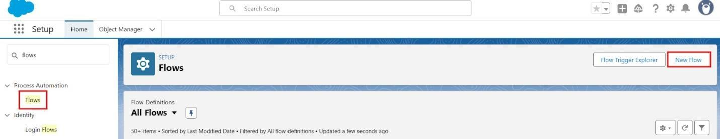

  - Select Record-Triggered Flow

  - Click Create

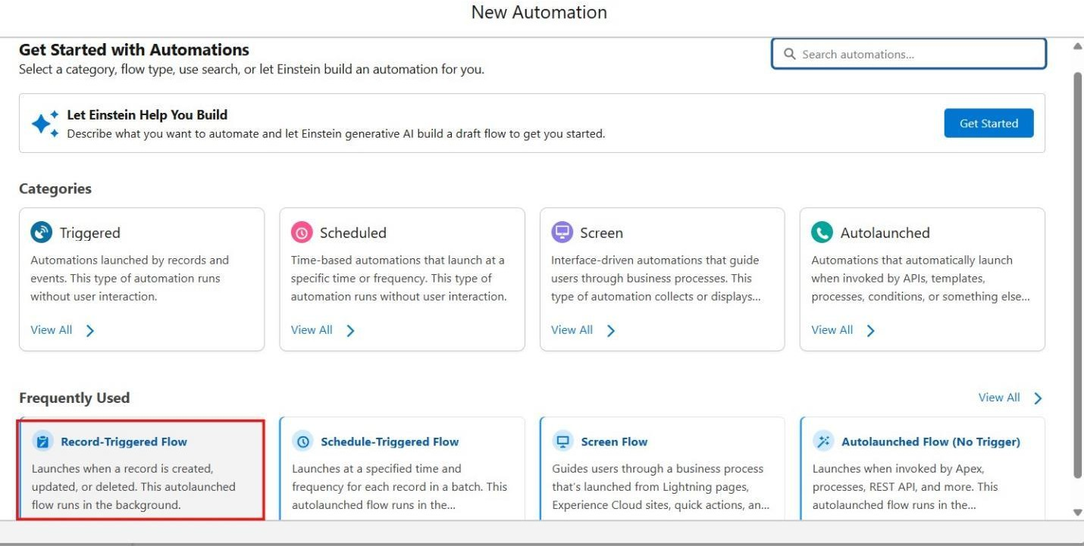

Step 2: Configure the Start (Trigger)

On the Start panel on the right:
  - Object: select Delivery_Update c

  - Trigger the Flow When:

- Select A record is created

  - Condition Requirements:

- Choose: None (Always Run the Flow)
- Optimize the Flow For

- Select Actions and Related Records

  - Click Done

  - ​

Part 2: Update Related Shipment Record Step 3: Add “Update Records” Element
  - Click the + icon under the Start element

  - Select Update Records

Configure the Update Records Element:
  - Label: Update_Shipment_Status

  - How to Find Records to Update:

- Select Specify conditions to identify records

Set Filter Conditions:
  - Object: Shipment c

  - Field: Id

  - Operator: Equals

  - Value: {!$Record.Shipment c}

(This means update the Shipment linked to the Delivery Update)

Set Field Values to Update Add field mapping:
Shipment Field | Value Source
Status c | {!$Record.Status c}

(This copies status from Delivery Update to Shipment)
  - Click Done

Part 3: Save and Activate Step 4:
Save Flow

  - Click Save (top-right)

  - Flow Label: Auto_Update_Shipment_Status

  - API Name will auto-fill

  - Click Save

Step 5: Activate Flow
  - Click Activate

  - Flow status should show Active

Final Flow Layout:

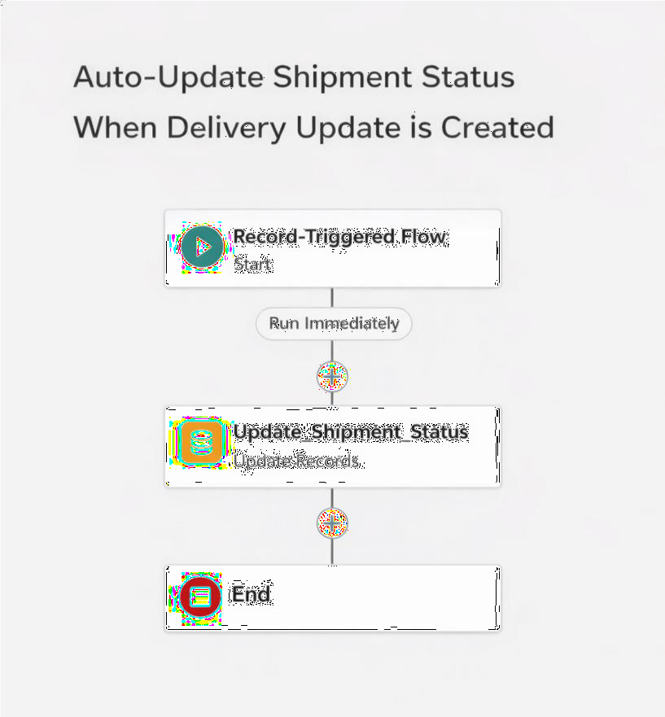

The Lightning App :

What is an App ?

Apps in Salesforce are a group of tabs that help the application function by working together as a unit. It has a name, a logo, and a particular set of tabs. The simplest app usually has just two tabs.

Create a Lightning App

Create the Courier Management System App
- From Setup, enter App Manager in the Quick Find and select App Manager.

- Click New Lightning App.

  - Enter the Courier Management System as the App Name.

- Upload an image or icon for the app, then click Next.
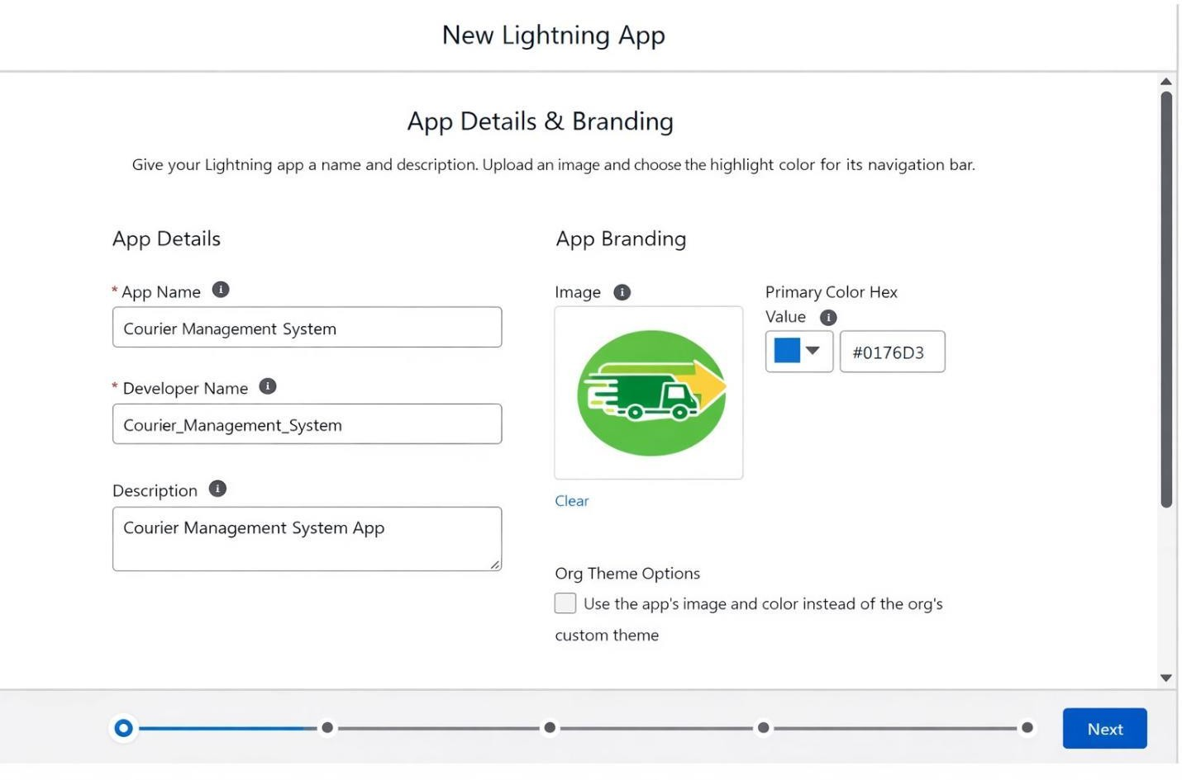

- Under App Options, leave the default selections and click Next.

- Under Utility Items, leave as it is and click Next.

- From Available Items, select the following and move them to Selected Items:

  - Customer

  - Shipment

  - Delivery Agent

  - Branch

  - Delivery Update

  - Invoice

  - Reports

  - Dashboards

- Click Next.

- From Available Profiles, select System Administrator and move it to Selected Profiles.

- Click Save & Finish.

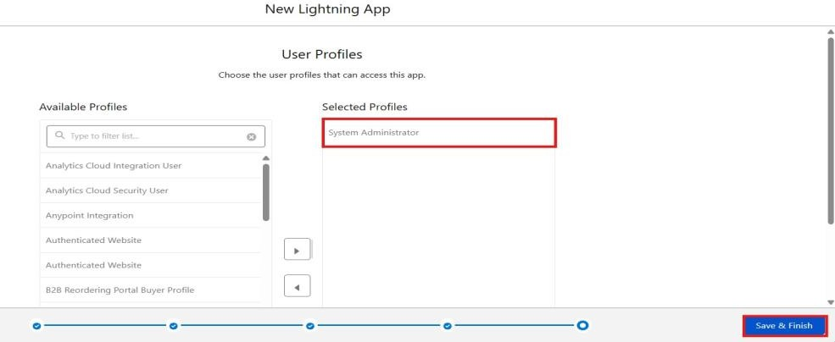

Profile:

What is a profile?

A profile is a group/collection of settings and permissions that define what a user can do in salesforce.
A profile can be assigned to many users, but users can be assigned a single profile at a time.

Create a Custom Profile – Courier Admin

Create a Custom Profile:
- From Setup, enter Profiles in the Quick Find box.

- Click Profiles.

- Click New Profile.
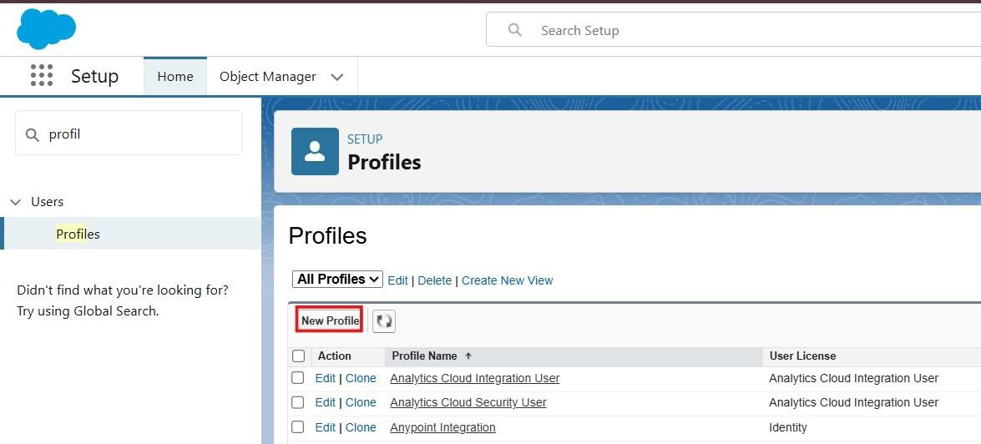

- Select Existing Profile as: System Administrator.

- Enter Profile Name: Courier Admin.

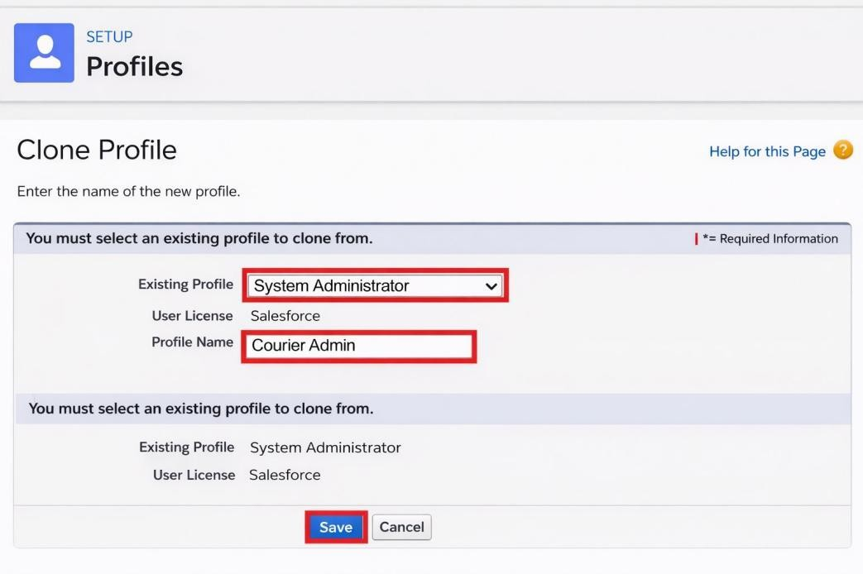
- Click Save.

Why use System Administrator as Base?
It already has:

  - Modify All Data

  - Customize Application

  - Full CRUD access on all objects

By cloning it, the Courier Admin profile automatically inherits full access. You can later restrict permissions if required.

Create a Custom Profile – Branch Manager

Steps:
- From Setup, enter Profiles in the Quick Find box.

- Click Profiles.

- Click New Profile.

- Select Existing Profile as: Standard Platform User.

- Enter Profile Name: Branch Manager.

- Click Save.

- Click Edit on the Branch Manager profile.

Set App & Tab Settings
Under Assigned Apps / Custom App Settings, set the default app to: Courier Management System App

Ensure Visible Tabs Include:
Set these tabs as Default On or Visible:

  - Customers

  - Shipments

  - Delivery Agents

  - Branches

  - Delivery Updates

  - Invoices

  - Reports

  - Dashboards

Custom Object Permissions

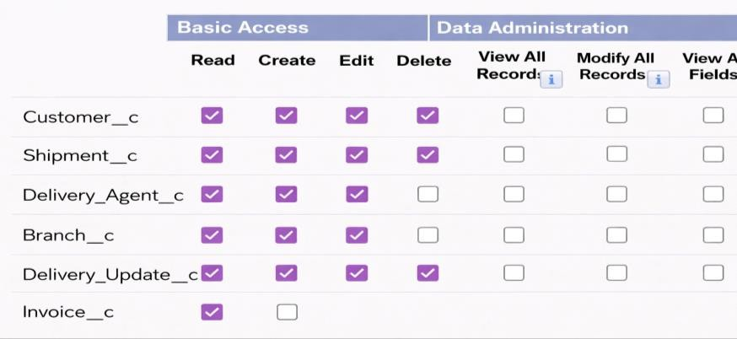

Scroll to Custom Object Permissions and set access as follows:
Object | Permissions to Grant
Customer c | Create, Read, Edit
Shipment c | Create, Read, Edit
Delivery_Agent c | Read, Edit
Branch c | Read, Edit
Delivery_Update c | Create, Read, Edit
Invoice c | Read

Create a Custom Profile – Delivery Agent
Object Permissions :
Object | Permissions
Shipment c | Read, Edit
Delivery_Update c | Create, Read, Edit
Customer c | Read
Invoice c | Read

Create a Custom Profile – Customer Support
Object Permissions :

Object | Access
Customer c | Read, Edit
Shipment c | Read, Edit
Delivery_Update c | Read
Invoice c | Read

Final Profiles Created in Project :

Profile Name | Purpose
Courier Admin | Full system control
Branch Manager | Manage shipments and agents
Delivery Agent | Update delivery status
Customer Support | Handle customers and tracking

Role:
In Salesforce, roles are used to determine which users have access to certain data and functions within the system. They are also used to define the reporting hierarchy within an organization.
Users with higher roles have greater access to data and more control over the system.

Creation of Courier Admin Role

Creation of Role:
- From the Quick Find box, search for Roles and click on the Roles option.

- Select Set Up Roles.
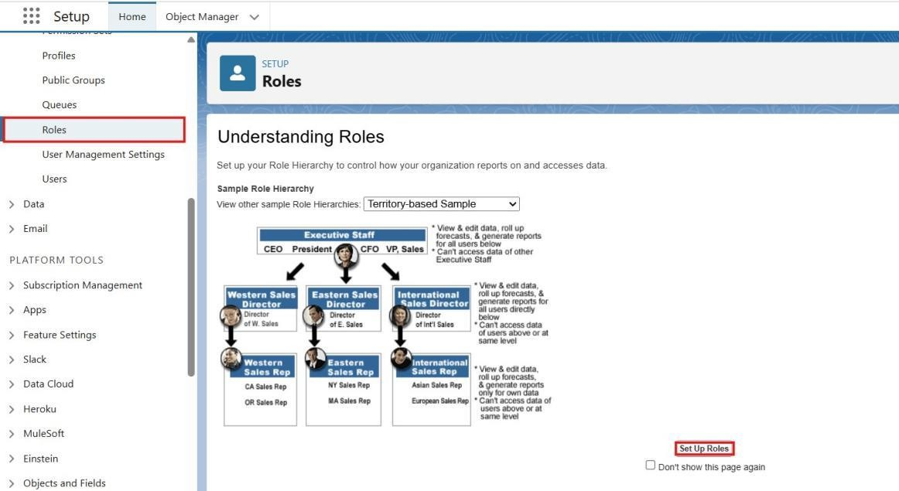
- Click on Expand All and click Add Role under CEO.
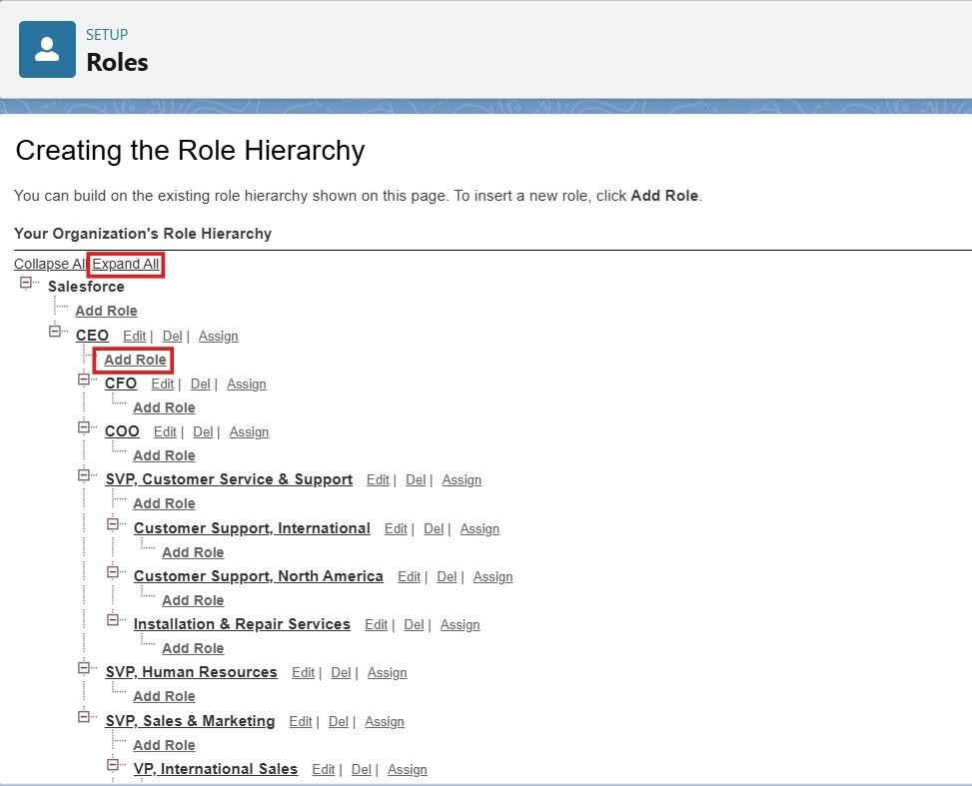

- Give Label as “Courier Admin”.

  - The Role Name will auto-populate.

- Click Save.

Creating Branch Manager Role Under Courier Admin Role

Create another role:
- Create a role with the name “Branch Manager”.

- Below the Courier Admin, click on Add Role.

- Enter the label name as “Branch Manager” and the Role Name will automatically populate.

- Click Save.

Creating Delivery Agent Role Under Branch Manager Role

Steps:
- Below the Branch Manager role, click on Add Role.

- Enter Label as “Delivery Agent”.

  - Role Name will auto-populate.

- Click Save.

Creating Customer Support Role Under Branch Manager

Steps:
- Under the Branch Manager role, click on Add Role.

- Enter Label as “Customer Support”.

- Role Name will automatically populate.

- Click Save.

Purpose of This Hierarchy :
  - Courier Admin – Highest level access to all data

  - Branch Manager – Manages branch-level operations

  - Delivery Agent – Access only to assigned shipments

  - Customer Support – Limited access to customer and shipment tracking

This hierarchy ensures proper data sharing and security in the Courier Management System.

User :

What is a user?

A user is anyone who logs in to Salesforce. Users are employees at your company, such as sales,reps, managers, and IT specialists, who need access to the company's records. Every user in Salesforce has a user account. The user account identifies the user, and the user account settings determine what features and records the user can access.

NOTE- As Salesforce license can only be used by 2 Users at a time in Dev Org, So If you don’t find a salesforce license then deactivate a user who has a salesforce license Or change the license type from Salesforce to any other.

To Create a User

Steps:
- From Setup, enter Users in the Quick Find box, then select Users.

- Click New User.

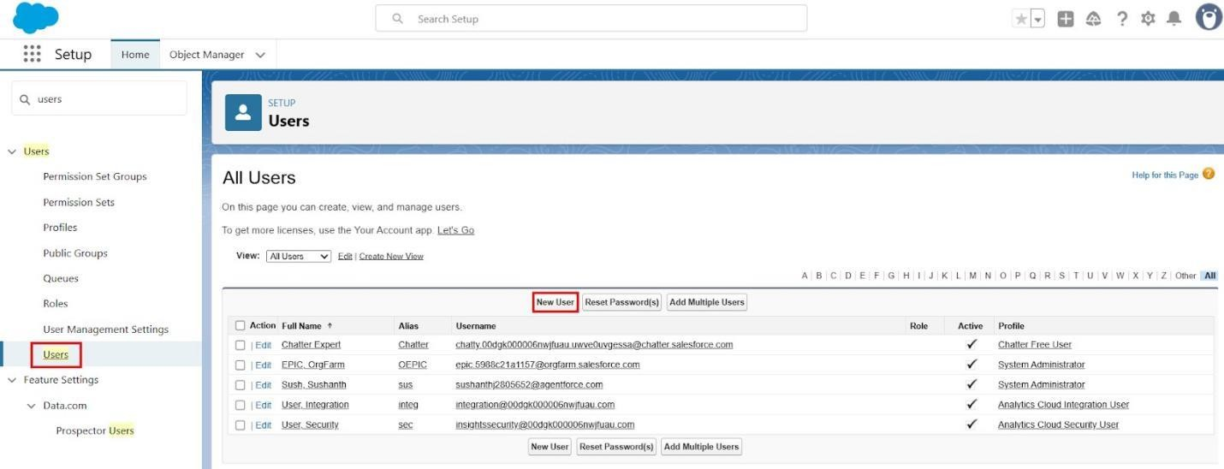

Fill in the Fields:

Field Name | Value
First Name | Enter first name (Example: Ravi)
Last Name | Enter last name (Example: Kumar)
Alias | Give an alias name
Email ID | Enter your personal email ID
Username | Must be in the format: text@text.text and must be unique
Nickname | Give a nickname
Role | Select Courier Admin

User License | Salesforce
Profile | Courier Admin

- Click Save.

Creating Other Users
Repeat the same steps as Activity 1 for creating additional users. Use the following details:
User Type | Role | User License | Profile
Branch Manager | Branch Manager | Salesforce | Branch Manager
Delivery Agent | Delivery Agent | Salesforce Platform | Delivery Agent
Customer Support | Customer Support | Salesforce Platform | Customer Support

Reports & Dashboards

Create Report Types

Step 1: Open Report Types
- Click Gear Icon → Select Setup.

- In Quick Find search Report Types.

- Click New Custom Report Type.

Step 2: Create Shipment Report Type
  - Primary Object: Shipment c

  - Label: Shipment Tracking Report

  - Category: Reports

  - Deployment Status: Deployed

  - Click Next → Save

Step 3: Create Customer Report Type
  - Primary Object: Customer c

  - Label: Customer Summary Report

  - Category: Reports Deployment Status: Deployed Click Next → Save

4: Create Agent Performance Report Type
Primary Object: Delivery_Agent c

  - Label: Agent Performance Report

  - Category: Reports

  - Deployment Status: Deployed

  - Click Next → Save Activity 2: Create Reports

Report 1: Shipment Status Summary Report Step 1: Create the Report
    - Click App Launcher (9 dots) → Search Reports

    - Click New Report

    - Choose Shipment Tracking Report

    - Click Continue Step 2: Add Columns
Add these fields:
  - Tracking Number

  - Customer

  - Status Expected Date
Assigned Agent

3: Add Filters
Show Me: All Shipments

  - Date Filter: This Month

  - Status Filter: Select specific Status (Optional)

Step 4: Group & Summarize

  - Group rows by Status c

  - Add summary on Price

Step 5: Save Report
  - Click Save & Run

  - Name: Shipment Status Summary

  - Folder: CMS Reports

Agent Performance Report Step 1: Create Report
  - New Report → Choose Agent Performance Report

  - Click Continue

Step 2: Add Columns
  - Agent Name

  - Branch

Number of Shipments Status

3: Group Data
Group by Delivery_Agent c

Step 4: Save Report

  - Name: Agent Performance Report

  - Folder: CMS Reports

  - Save & Run

Report 3: Revenue Report Steps
  - Create report using Shipment Tracking Report Type

Add fields:
  - Tracking Number

  - Customer

Create Dashboard

Step 1: Open Dashboards
- Click App Launcher (9 dots)

- Search Dashboards

- Click New Dashboard

Step 2: Enter Dashboard Details
  - Name: Courier Management Dashboard

  - Folder: CMS Reports

  - Click Create

Add Dashboard Components

Shipment Status Overview (Donut Chart)
- Click + Component

- Choose report: Shipment Status Summary

- Visual Type: Donut Chart

- Click Add

Agent Performance (Bar Chart)
  - Select report: Agent Performance Report

  - Chart Type: Bar Chart

  - Click Add

Revenue by Branch (Column Chart)
  - Choose report: Revenue by Branch Report

  - Chart Type: Column Chart

  - Click Add

Save & Activate Dashboard
- Click Save

- Click Done

Share Dashboard With:
  - Courier Admin

  - Branch Managers

  - Customer Support Team

Final Layout :
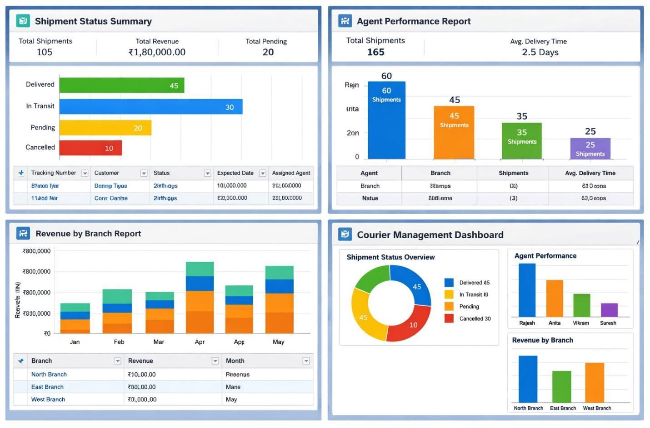

FUNCTIONAL & PERFORMANCE TESTING

During testing, screenshots were captured from Salesforce to verify record creation, validation rule enforcement, delivery status updates, flow automation, invoice generation, and dashboard visualization. All scenarios were validated to ensure correct performance and reliability.

- ADVANTAGES & DISADVANTAGES
Advantages

  - Centralized data
  - Automated workflows

  - Real-time reporting

Disadvantages

  - Salesforce dependency
  - Requires initial configuration effort

OUTPUT AND SCREENSHOTS

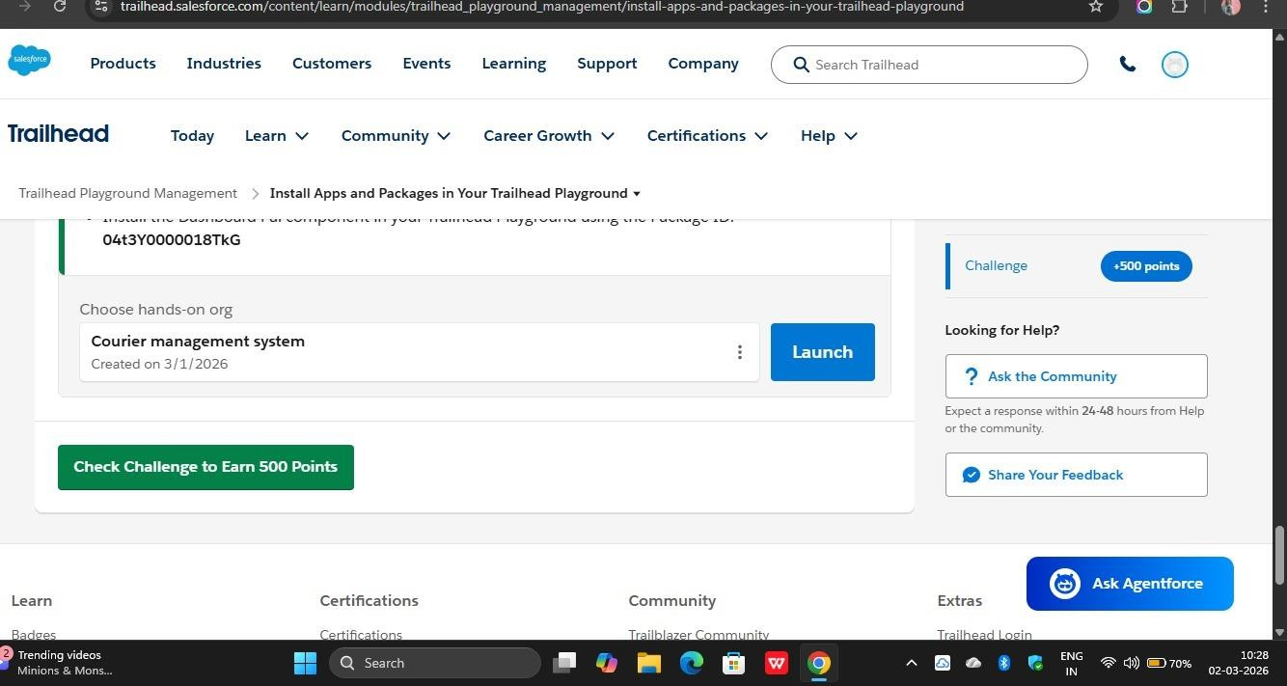

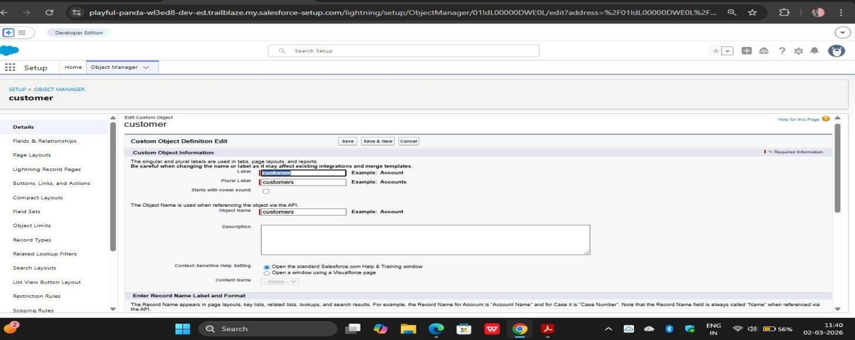

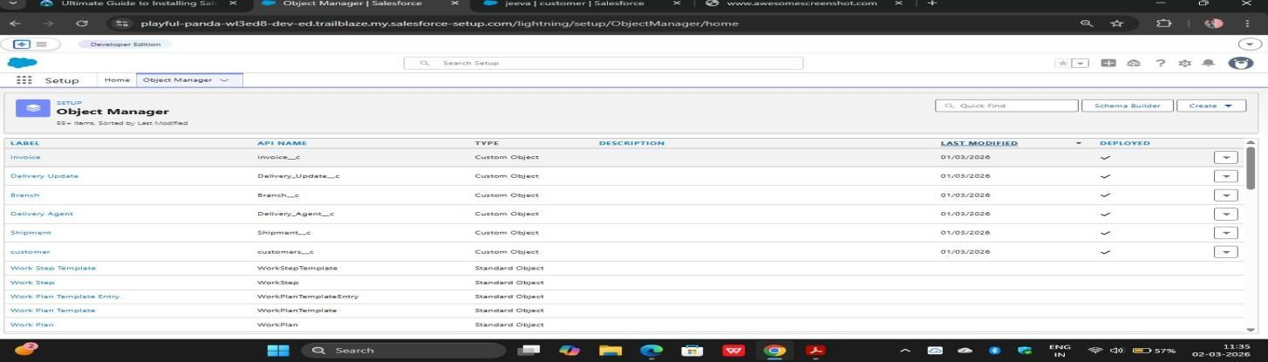

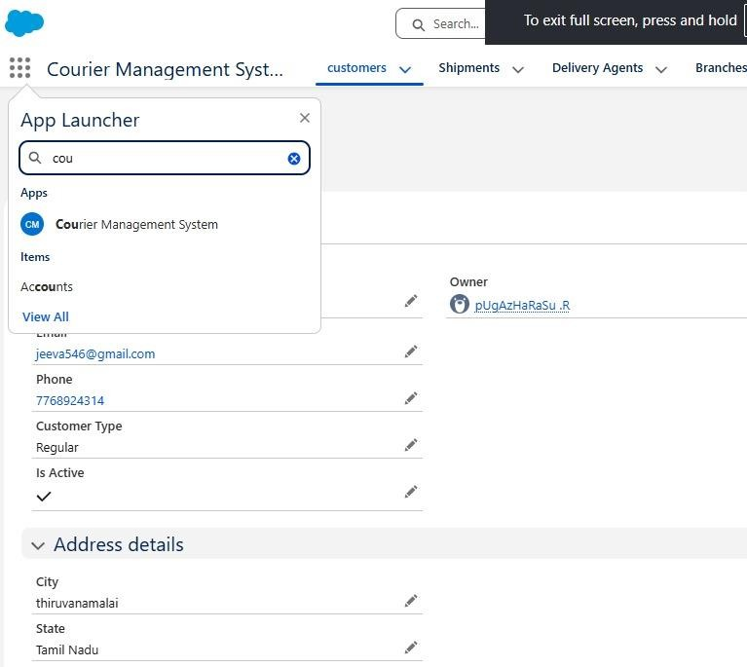

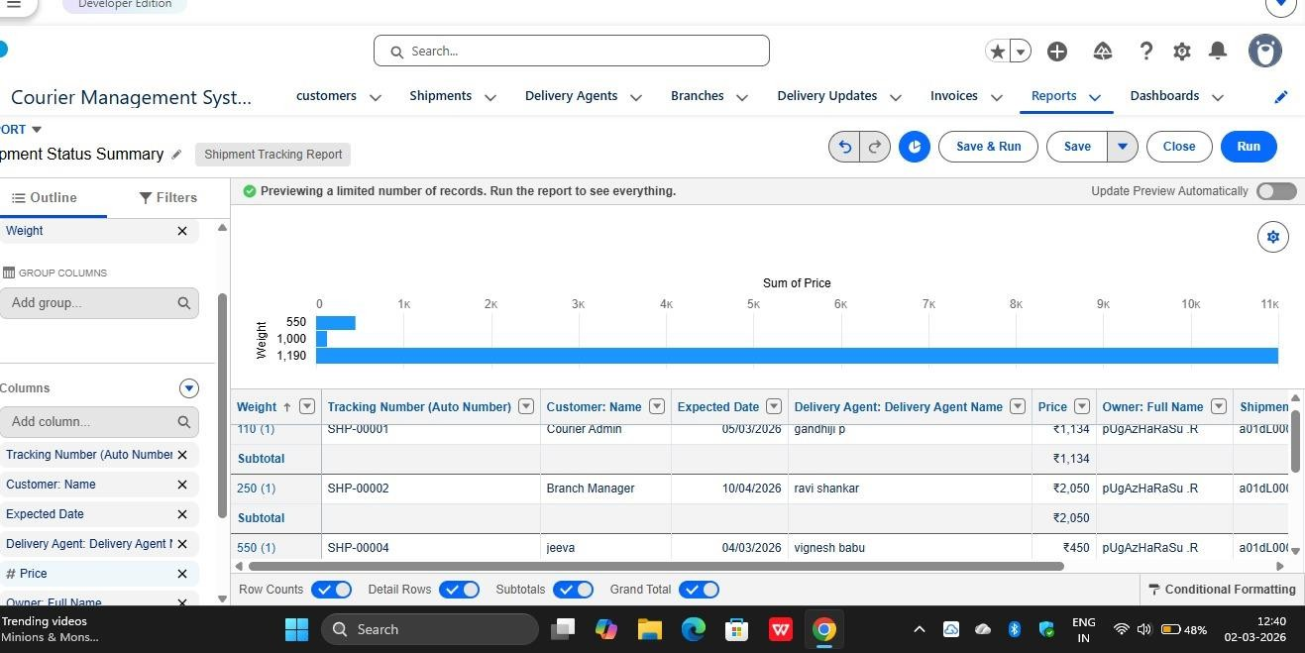



- Conclusion
The Courier Management System successfully digitizes courier operations using Salesforce automation, improving efficiency, accuracy, and customer satisfaction.

- FUTURE SCOPE
  - Mobile tracking app
  - GPS integration
  - SMS notifications
  - AI-based delivery optimization

- APPENDIX
  - Source Code: Salesforce Configuration
  - Dataset: Salesforce Objects
  - GitHub / Demo: Salesforce Developer Org

Thank You

